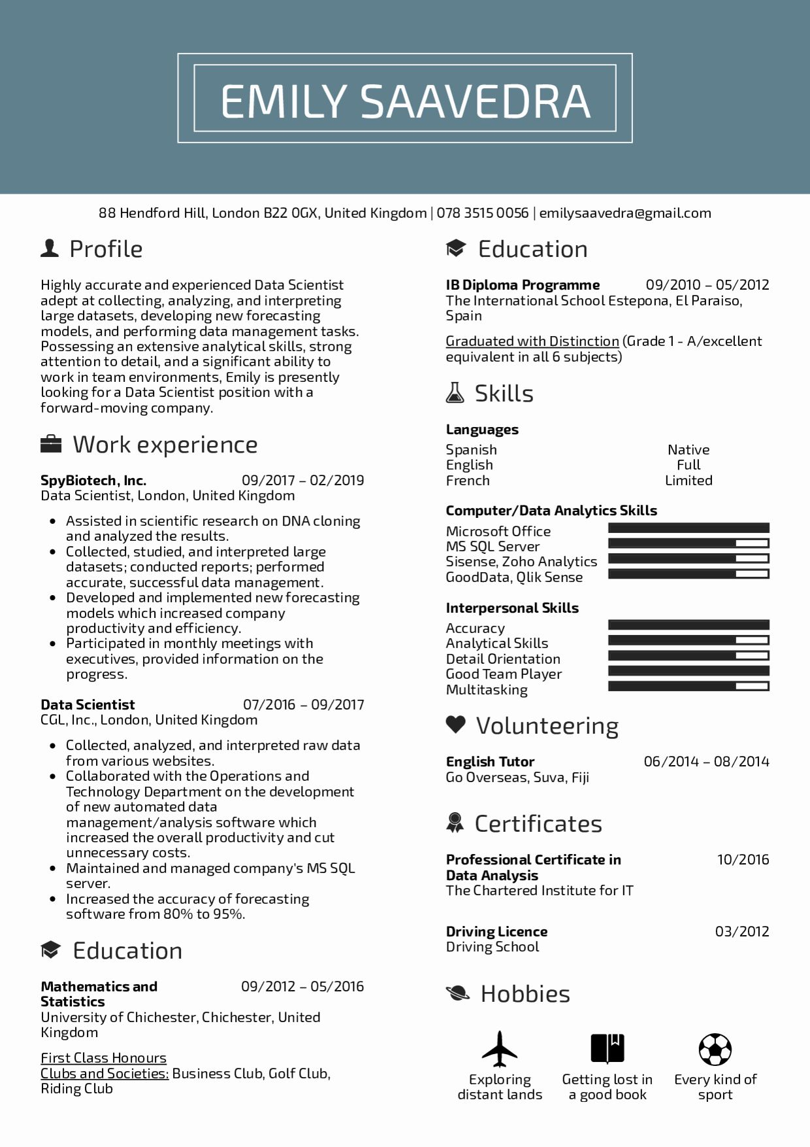
EMILY SAAVEDRA
88 Hendford Hill, London B22 OGX, United Kingdom | 078 3515 0056 | emilysaavedra@gmail.com
Profile
Highly accurate and experienced Data Scientist adept at collecting, analyzing, and interpreting large datasets, developing new forecasting models, and performing data management tasks. Possessing an extensive analytical skills, strong attention to detail, and a significant ability to work in team environments, Emily is presently looking for a Data Scientist position with a forward-moving company.
Work experience
SpyBiotech, Inc.
Education
IB Diploma Programme
09/2010 05/2012
The International School Estepona, El Paraiso, Spain
Graduated with Distinction (Grade 1 - A/excellent equivalent in all 6 subjects)
Skills
Languages
Spanish
Native
English
Full
09/2017 02/2019
French
Limited
Computer/Data Analytics Skills
Data Scientist, London, United Kingdom
• Assisted in scientific research on DNA cloning and analyzed the results.
• Collected, studied, and interpreted large
datasets; conducted reports; performed accurate, successful data management.
• Developed and implemented new forecasting models which increased company productivity and efficiency.
Participated in monthly meetings with executives, provided information on the progress.
Data Scientist
07/2016-09/2017
CGL, Inc., London, United Kingdom
• Collected, analyzed, and interpreted raw data from various websites.
• Collaborated with the Operations and Technology Department on the development of new automated data
management/analysis software which increased the overall productivity and cut unnecessary costs.
• Maintained and managed company's MS SQL
server.
• Increased the accuracy of forecasting
software from 80% to 95%.
Education
Mathematics and
Statistics
09/2012-05/2016
University of Chichester, Chichester, United Kingdom
First Class Honours
Clubs and Societies: Business Club, Golf Club, Riding Club
Microsoft Office
MS SQL Server
Sisense, Zoho Analytics
GoodData, Qlik Sense
Interpersonal Skills
Accuracy Analytical Skills Detail Orientation Good Team Player Multitasking
❤ Volunteering
English Tutor
Go Overseas, Suva, Fiji
Certificates
Professional Certificate in Data Analysis
The Chartered Institute for IT
Driving Licence
Driving School
Hobbies
Exploring
distant lands
06/2014 08/2014
10/2016
03/2012
Getting lost in a good book
Every kind of sport

